**“Experiment 1.3”**

Student Name: **SUMIT KUMAR** UID: **20BCS8226**

Branch: **CSE**  Section/Group: **808-A**

Semester: **5** Date of Performance: **18-08-22**

Subject Name: **Design and Analysis of Algorithms Lab** Subject Code: **20CSP-312**

**1. Aim/Overview of the practical:**

In O(n) time complexity, find the frequency of elements in a given array.

**2. Algorithm/Flowchart (For programming based labs):**

Step 1: Input the number of elements of an array.

Step 2: Input the array elements.

Step 3: Create another array to store the frequency of elements.

Step 4: Traverse the input array and update the count of the elements in the frequency array.

Step 5: Print the frequency array which displays the frequency of all the elements of the

array.

**3. Steps for experiment/practical/Code:**

// SUMIT KUMAR

// 20BCS8226

#include <bits/stdc++.h>

using namespace std;

void countFreq(int arr[], int n)

{

// Mark all array elements as not visited

vector<bool> visited(n, false);

// Traverse through array elements and

// count frequencies

for (int i = 0; i < n; i++) {

// Skip this element if already processed

if (visited[i] == true)

continue;

// Count frequency

int count = 1;

for (int j = i + 1; j < n; j++) {

if (arr[i] == arr[j]) {

visited[j] = true;

count++;

}

}

cout<<"Frequency of "<<arr[i]<< " is : "<<count<<endl;

}

}

int main()

{

int arr[] = { 7, 7, 4, 5, 6, 5, 4, 4, 3, 1, 2, 1};

int n = sizeof(arr) / sizeof(arr[0]);

countFreq(arr, n);

return 0;

} **4. Observations/Discussions/ Complexity Analysis:**

This approach will result in linear complexity, i.e., O(n) time complexity. Here, n is the number of elements present in the given array.

**5. Result/Output/Writing Summary:**

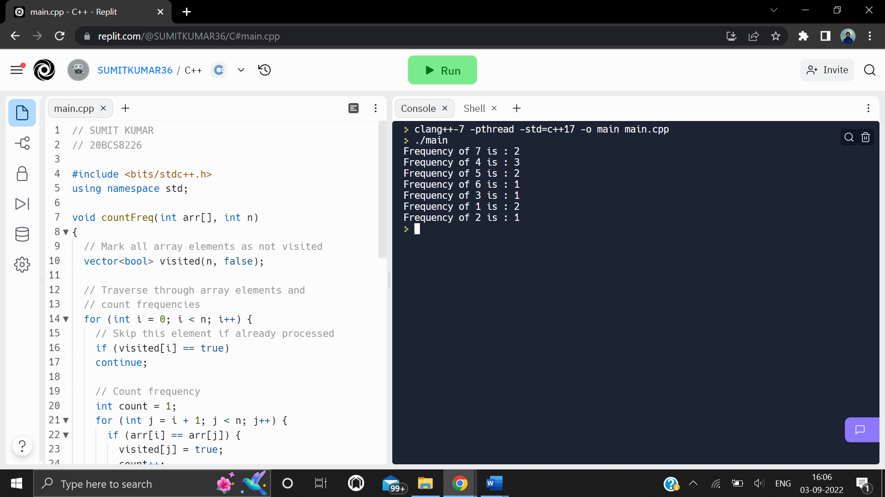

**Learning outcomes (What I have learnt):**

**1.** Learnt about a way of calculating frequency of each element.

**2**. Learnt how to implement know frequency in linear time complexity.

**3**. Learnt faster method of calculating frequency of elements in an array.

**Evaluation Grid (To be created as per the SOP and Assessment guidelines by the faculty):**

|  |  |  |  |
| --- | --- | --- | --- |
| Sr. No. | Parameters | Marks Obtained | Maximum Marks |
| 1. |  |  |  |
| 2. |  |  |  |
| 3. |  |  |  |
|  |  |  |  |